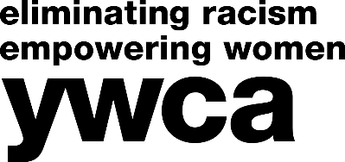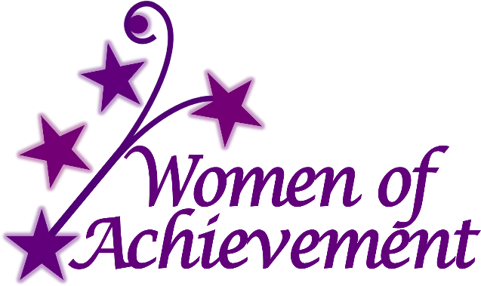

37th Annual Women of Achievement Awards Luncheon

March 27, 2020 - 11:30AM – 1:00PM
Rivers Casino & Resort Event Center, Schenectady, NY

Honoring women from throughout the Capital Region for their extraordinary achievements!

2020 Nomination Form

YWCA NorthEastern NY is pleased to announce the 37th Annual Women of Achievement Awards. YWCA NENY will be recognizing outstanding women who have demonstrated extraordinary achievement in their career and/or community involvement. Nominees will have demonstrated remarkable accomplishments in categories such as Business, Diversity & Inclusion, Medicine, Education, Volunteerism, Law, Health & Human Services, Philanthropy, Community Development, Empowering Women, and more.

The nominator may involve the nominee in preparing the application to obtain correct and complete information. The nominator may choose to identify herself/himself or remain anonymous. Women who have been nominated in previous years for YWCA NENY’s Women of Vision or Women of Achievement Award and have not been selected may be nominated again. Current members of YWCA NorthEastern NY’s Board of Directors and staff may not be nominated.

The awardees will be recognized at the 37th Annual Women of Achievement Awards Luncheon to be held Friday, March 27, 2020 at the Rivers Casino & Resort Event Center in Schenectady, NY from 11:30AM - 1:00PM. The awardees are expected to be announced by November 30, 2019.

Applications are due by October 23, 2019 and may be emailed to kmchale@ywca-neny.org or mailed to Women of Achievement, YWCA NorthEastern NY, 44 Washington Avenue, Schenectady, NY 12305. Should you have any questions, call Kindra McHale at YWCA NENY, 518-374-3394 ext. 105. To see who has been awarded in the past, please visit http://www.ywca-neny.org/academy/. Please note that nominees can only win once.

Nominee’s Name: ___________________________________________________________________

Nominee’s Title: ____________________________________________________________________

Nominee’s Address: _________________________________________________________________

Nominee’s Phone Number: ___________________________________________________________

Nominee’s Email Address: ____________________________________________________________

Nominator’s Name: __________________________________________________________________
☐ Please check here if you wish to remain anonymous.

Nominator’s Phone Number: __________________________________________________________

Nominator’s Email Address: ___________________________________________________________

Nominating Affiliation Name: __________________________________________________________

Nominating Affiliation Address: _________________________________________________________

Women of Achievement
2020 Nomination Form - Page 2

IMPORTANT: Describe community roles and responsibilities of nominee. Be specific, be thorough and write as if the reader knows NOTHING of your nominee. More detail is better! Use as much space as needed for each question. Please answer each question to the best of your ability.
PLEASE NOTE: In order to maintain a fair selection process, the name of the nominee SHOULD NOT be given in the answers. Please only use she/her/nominee.

Nomination Deadline: October 23, 2019

Category Nomination
(please check one category or fill in the blank to suggest a category not listed)

__ Business __ Diversity & Inclusion __ Medicine
__ Education __ Health & Human Services __ Volunteerism
__ Empowering Women __ Community Development __ Philanthropy

__ Law __ Arts & Humanities

__ Other (please fill in the blank) _________________

- Describe why the nominee deserves the award in chosen category?

- Explain how the nominee has positively impacted the local community – include specific programs, events, activities, etc.

- Describe the nominee’s traits that make her a role model for others.

- List any other significant reasons why your candidate should be considered for this award.

