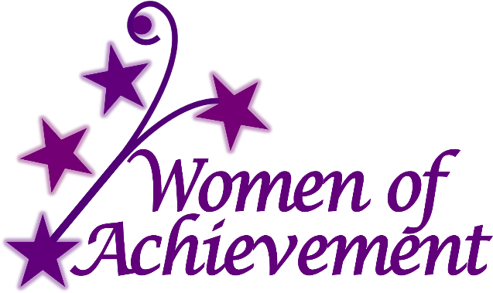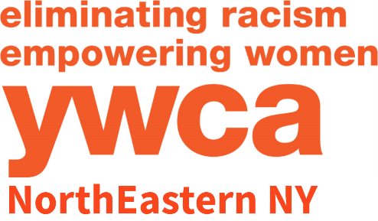
36th Annual Women of Achievement Awards Luncheon
Presented by Druthers Brewing Company
March 29, 2019 - 11:30AM – 1:00PM
Mallozzi’s Ballroom, 1930 Curry Rd, Schenectady, NY 12303

Honoring Women from throughout the Capital Region for their extraordinary achievements!

2019 Nomination Form

YWCA NorthEastern NY is pleased to announce the 36th Annual Women of Achievement Awards Luncheon, presented by Druthers Brewing Company, will be recognizing outstanding women who have demonstrated extraordinary achievement in their career and/or community involvement. Nominees have demonstrated remarkable accomplishments in categories such as Business, Diversity & Inclusion, Medicine, Education, Volunteerism, Law, Health & Human Services, Philanthropy, Community Development, Empowering Women, and more.

The nominator may involve the nominee in preparing the application to obtain correct and complete information, however, nominations may also be anonymous. Women who have been nominated in previous years for the YWCA’s Women of Vision or Women of Achievement Award and have not been selected may be nominated again. Current members of the YWCA Board of Directors and staff may not be nominated.

The awardees will be recognized at the YWCA Women of Achievement Awards Luncheon to be held Friday, March 29, 2019 at the Mallozzi’s Ballroom in Schenectady, NY 11:30AM - 1:00PM. The awardees are expected to be announced by November 30, 2018.

Applications are due by October 15, 2018 and may be emailed to lhutson@ywca-neny.org or mailed to Women of Achievement, YWCA NorthEastern NY, 44 Washington Avenue, Schenectady, NY 12305. Should you have any questions, call Elizabeth Hutson at the YWCA, 518-374-3394 ext. 105 or email lhutson@ywca-neny.org.

Nominee’s Name: ___________________________________________________________________

Nominee’s Title: ____________________________________________________________________

Home Address: _____________________________________________________________________

Phone Number: ____________________________________________________________________

Nominee’s Email Address: ____________________________________________________________

Nominator’s Name (Anonymous Nominators allowed): ___________________________________________

Nominator’s Phone Number: __________________________________________________________

Nominator’s Email Address: ___________________________________________________________

Nominating Affiliation Name: __________________________________________________________

Nominating Affiliation Address: _________________________________________________________

Women of Achievement
2019 Nomination Form - Page 2

IMPORTANT: Describe community roles and responsibilities of nominee. Be specific, be thorough and write as if the reader knows NOTHING of your nominee. More detail is better! Use as much space as needed for each question. Please answer each question to the best of your ability.

Nomination Deadline: October, 15th 2018

Category Nomination
(please check one category or fill in the blank to suggest a category not listed)

__ Business __ Diversity & Inclusion __ Medicine
__ Education __ Health & Human Services __ Volunteerism
__ Law __ Community Development __ Philanthropy

__ Empowering Women __ Other (please fill in the blank) ________________

- Describe why the nominee deserves the award in chosen category?

- Explain how the nominee has positively impacted the local community – include specific programs, events, activities, etc.

- Describe the nominee’s traits that make her a role model for others.

- List any other significant reasons why your candidate should be considered for this award.

