Women of Achievement

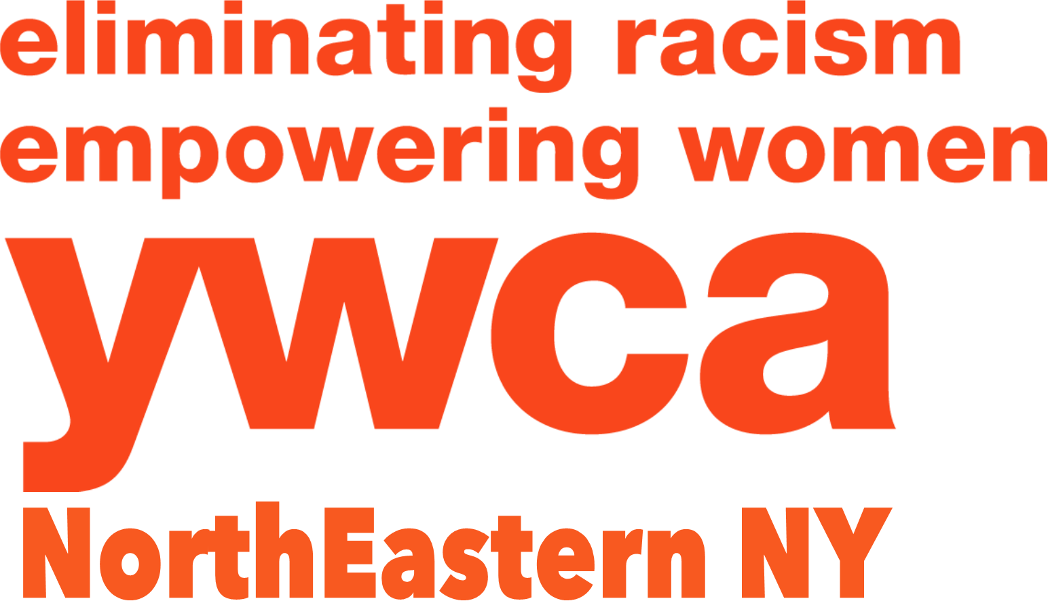
2018 Nomination Form - Page 1

The Women of Achievement Award will be presented to five outstanding women who have demonstrated extraordinary achievement in their career and/or community involvement and have worked to eliminate discrimination and empower women. These nominees have supported others or personally overcome racial, societal or professional barriers while serving as role models.

This is a competitive award. A selection committee reviews the nominations objectively. The name, address, employer and job title of each nominee is withheld from the judges. Instead, judges allocate points based on the nominator’s description of the nominee’s role or service, accomplishments, traits and responsibilities that are consistent with and fulfill the YWCA’s mission of eliminating racism, empowering women and promoting peace, justice, freedom, and dignity for all. To assist the nominator, the maximum number of points allocated for each question is indicated on the application form.

The nominator may involve the nominee in preparing the application to obtain correct and complete information. Women who have been nominated in previous years for the YWCA’s Women of Vision or Women of Achievement Award and have not been selected may be nominated again. Current members of the YWCA Board of Directors and staff may not be nominated.

The awardees will be recognized at the YWCA Women of Achievement Celebration to be held Thursday, March 8, 2018 at The Glen Sanders Mansion in Scotia, NY. The awardees are expected to be announced by January 18, 2018.

Applications are due by January 15, 2018 (there are no exceptions) and may be emailed to funddevelopment@ywca-neny.org or mailed to Women of Achievement, YWCA NorthEastern NY, 44 Washington Avenue, Schenectady, NY 12305. Should you have any questions, call Jo-Anne Rafalik at the YWCA, 518-374-3394 ext. 105 or email funddevelopment@ywca-neny.org.

Nominee’s Name:
Nominee’s Title:
Home Address:
Phone Number:
Nominee’s Email Address:
Nominator’s Name:
Nominator’s Phone:
Nominator’s Email Address:
Nominating Affiliation Name:
Nominating Affiliation Address:

Candidate #___________
Women of Achievement
2018 Nomination Form - Page 2

IMPORTANT: Do not use the applicant’s name, employer or title(s). Refer to your nominee as “she” or “her”. Describe community roles and responsibilities of nominee. Be specific, be thorough and write as if the reader knows NOTHING of your nominee. More detail is better! Use as much space as needed for each question. Please be sure to answer each question.

Nomination Deadline: January 15, 2018

- Describe how the nominee has worked or volunteered in our community to support the YWCA mission of eliminating racism. (20 points)

- Describe how the nominee has worked or volunteered in our community to support the YWCA mission of empowering women. (20 points)

- Describe how the nominee has worked or volunteered in our community to support the YWCA mission of promoting peace, justice, freedom, and dignity for all. (20 points)

- Summarize any achievements of the nominee in racial and social justice work, advocacy for women or financial empowerment of women – include detail about contributions for the benefit of others and/or overcoming racial, societal or professional barriers in her own life. (15 points)

- Explain how the nominee has positively impacted the local community – include specific programs, events, activities, etc. (15 points)

- Describe the nominee’s traits that make her a role model for others. (5 points)

- List any other significant reasons why your candidate should be considered for this award.
(5 points)

Candidate #___________

