YWCA NorthEastern NY

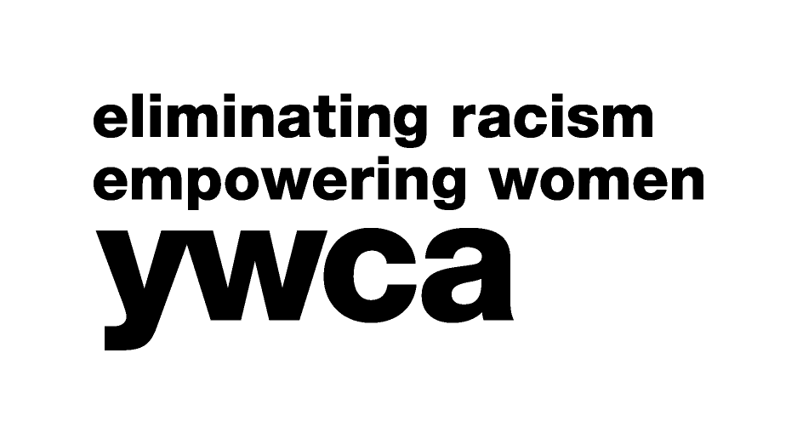

Women of Achievement

Contract for 2017 Dinner Program Book

This advertising contract is made between the YWCA NorthEastern NY and:

Advertiser’s Company/Organization: __________________________________________

Address: ____________________________________________________________

____________________________________________________________

Contact Person: ______________________________________Phone:________________

Email Address: ____________________________________________________________

Ad Size Desired: ________________________ Payment enclosed: ____________________

Ad sizes and rates: Width and Depth Price

Full Page 4 ½” x 7 ½” $150

Three Quarters Page 4 ½” x 5 3/5” $125

One Half Page 4 ½” x 3 3/4” $100

One Quarter Page 4 ½” x 1 9/10” $ 75

Copy Deadline: March 14, 2017

Please attach your ad copy and return to: YWCA NorthEastern NY, 44 Washington Avenue, Schenectady, NY 12305-1799. For more information, call Jo-Anne Rafalik at the YWCA,
374-3394 (ext. 105) or email to: funddevelopment@ywca-neny.org (please send pdf version with an attached company logo).

