Women of Achievement
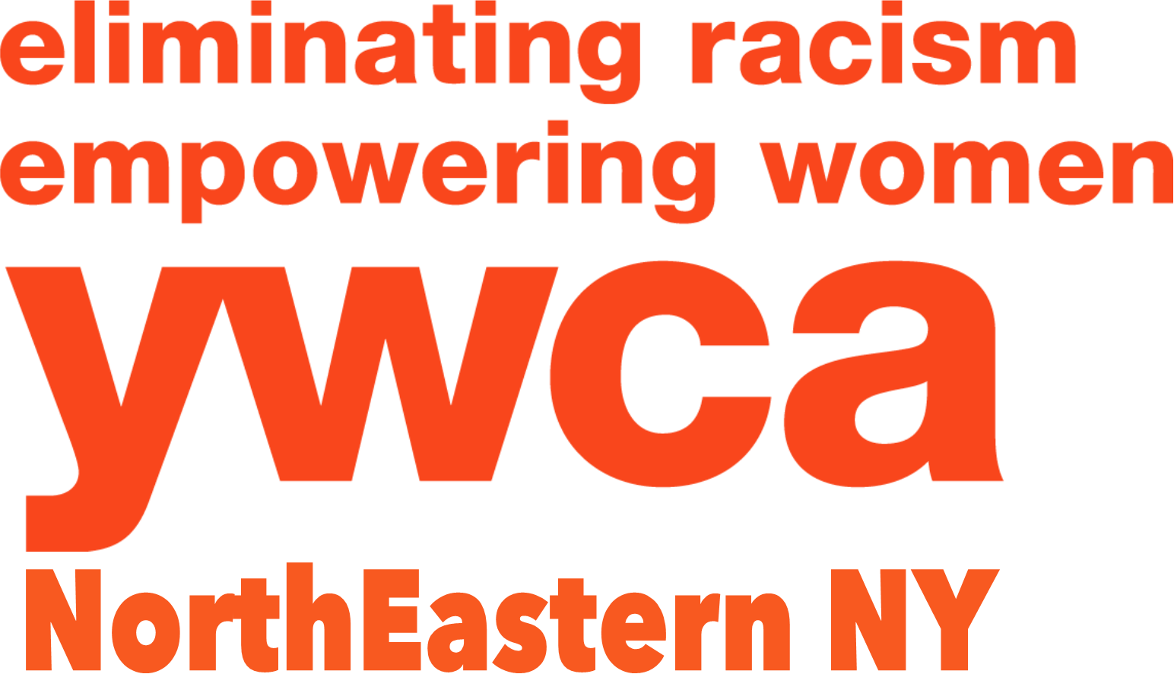
2017 Nomination Form - Page 1
northeastern ny

The Women of Achievement Award will be presented to at least five outstanding women who have demonstrated unusual achievement and distinction in career and/or community work and have made a difference in the elimination of discrimination on the basis of race, gender or creed. These nominees have overcome or helped to eliminate any racial, societal or professional barriers while serving as role models through the leadership qualities they exhibit. This is a competitive award. A selection committee composed of members of the Academy of Women of Achievement judges the nominees. To insure objectivity, selection is made using an objective point system; applicant’s names, employer (corporate name) and job titles are unknown to the judges. Instead, describe traits, roles, responsibilities, accomplishments, industries, services and clients. Ex: “She serves in a leadership capacity at a local college where she…”

To assist the nominator with understanding where the emphasis lies, the maximum number of points allocated for each question is indicated on the application form. It is recommended that the nominator involve the Academy nominee in preparing the application in order to obtain correct and complete information. Women who have been nominated in previous years for the YWCA’s Women of Vision or Woman of Achievement Award and have not been selected may be nominated again. Current members of the YWCA Board of Directors and staff may not be nominated.

In terms of completing the application, please write the nomination application as if the reader knows nothing about the woman being nominated; be specific and thorough, use no acronyms or make any assumptions. More is better in terms of length of application to help the Selection Committee understand the depth of achievement that your nominee has gained.

The women selected as awardees will be recognized, as guests of the YWCA at the Women of Achievement Celebration to be held Thursday, March 30, 2017 at The Glen Sanders Mansion in Scotia, NY. As new members of the Academy of Women of Achievement, their names will be added to a permanent plaque on display at the YWCA; they will be listed in all future award programs and will receive a free YWCA membership for the year following the award. We may invite awardees to contribute their leadership skills and talents in the future to work with the YWCA NorthEastern NY.

Applications are due by January 20, 2017 (there are no exceptions). Please return the nomination application by emailing to: funddevelopment@ywca-neny.org or mail to: Women of Achievement, YWCA NorthEastern NY, 44 Washington Avenue, Schenectady, NY 12305. Should you have any questions, call Jo-Anne Rafalik at the YWCA, 518-374-3394 ext. 105. Please feel free to forward any questions to funddevelopment@ywca-neny.org.

Nominee’s Name:
Nominee’s Title:
Home Address :
Phone Number:
Nominee’s Email Address:
Nominator’s Name:
Nominator’s Phone:
Nominator’s Email Address:
Nominating Affiliation Name:
Nominating Affiliation Address:

Selected nominees will be notified by February 1, 2017. Candidate #___________

Women of Achievement
2017 Nomination Form - Page 2

IMPORTANT: Please do not use the applicant’s name, employer or title (s). Refer to your nominee as “she” or “her”. Describe industry (products, services or clients) and responsibilities of nominee. Be specific, be thorough and write as if the reader knows NOTHING of your nominee – More is Better!! Use as much space as needed for each question. Please be sure to answer each question.

Nomination Deadline: January 20, 2017

- Summarize your nominee’s areas of significant achievement in business, cultural, and/or voluntary sectors of the community.
(10 points)

- How has this individual positively impacted the local community (specific programs, activities, etc)?
(15 points)

- Describe any traits that would compel others to view the nominee as a role model. (10 points)

- Describe how the nominee has helped or supported other women within her own or in other fields. (30 points)

- Describe any contributions the nominee has made toward the elimination of discrimination on the basis of race, gender or creed, and how the nominee has overcome or helped to eliminate any racial, societal or professional barriers.
(30 points)

- List any other significant reasons why your candidate should be considered for this award.
(5 points)

Candidate #___________

