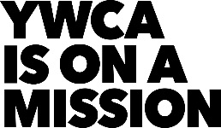
YWCA NorthEastern NY
Year End Evaluation
Report Year:___________

Program/Department:______________________________________________________

Person Completing Report:__________________________________________________

- People Served:

Number of people served this year
Number of people not served due to lack of available slots
Number of people waiting to be served at end of year
(due to waiting list)

II. Major Accomplishments During This Year:
(Use additional sheets if necessary.)

III. Problems Encountered During This Year and Corrective Action Taken:
(Use additional sheets if necessary.)

IV. Difficulties Accomplishing Yearly Goals and Objectives:
Objectives must reflect those described in yearly goals and objectives report.
(Use additional sheets if necessary.)

V. Plans for next year:

Plans include anything new or continuing that the agency/program will attempt to accomplish in the next year.
(Use additional sheets if necessary or attach goals and objectives for New Year.)

VI. Staffing Changes:
Changes include new hires, terminations, changes in position or changes in salary.

Title or  Position | Previous  Salary | New  Salary | Effective  Date | Reason For Change

