Women of Achievement
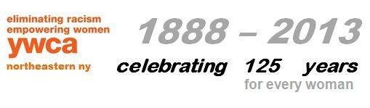
Nomination Form for 2016 REACH Awards

We would like to participate in the YWCA 2016 REACH Awards at the following level:
____Level One: $150 ____Level Two: $250

Company Name: ________________________________________________________________
Company Address:_______________________________________________________________
Company Phone:__________________________ Email Address:__________________________
Contact Name:__________________________________________________________________

Please provide the following information about each of your nominees:
Name of Nominee:_______________________________________________________________
Title of Nominee:________________________________________________________________
Address of Nominee: ____________________________________________________________
Phone of Nominee: _____________________Email Address of Nominee:___________________
A brief description of the nominee’s contribution to your company
- What makes this person special to your company?

- Why are you selecting her?

There are two levels to choose from for sponsoring nominees from your business to be honored with the YWCA NorthEastern NY Reach Award at the Women of Achievement event:
Level One: For a cost to your company of $150 you will receive: | Level Two: For a cost to  your company of $250 you will receive:
- An award for one honoree from your company.  - One complimentary dinner provided to the honoree.  - 1/2 page ad for your company  in the program book.  - Recognition for the honoree and your company in the dinner’s program book and the announcement of same at the dinner.  - Certificate of Achievement presented to your honoree.  - One year membership to the YWCA NorthEastern NY for your honoree. | - An award for two honorees from your company.  - Two complimentary dinners provided to the honorees.  - Full page ad for your company  in the program book.  - Recognition for the honorees and your  company in the dinner’s program book and  the announcement of same at the dinner.  - Certificate of Achievement presented to your honorees.  - One-year membership to the YWCA NorthEastern NY for your honorees.

Please email the completed form to funddevelopment@ywca-neny.org.

Please make your check payable to the YWCA NENY, mail it by February 29, 2016 to:
REACH Awards, YWCA NorthEastern NY, 44 Washington Ave, Schenectady, NY 12305.

If you have any questions, contact Jo-Anne Rafalik at the YWCA, 518-374-3394 ext 105, or email: funddevelopment@ywca-neny.org

