Women of Achievement
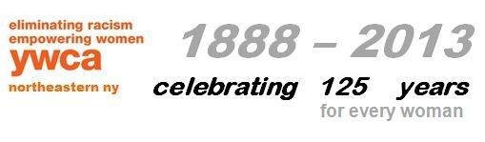
Nomination Form for 2016 REACH Awards
Due: February 29, 2016

We would like to participate in the YWCA 2016 REACH Awards:

Company Name: ________________________________________________________________

Company Address:_______________________________________________________________

Company Phone:__________________________ Email Address:__________________________

Contact Name:__________________________________________________________________

Please provide the following information about each of your nominees:
Name of Nominee:_______________________________________________________________

Title of Nominee:________________________________________________________________
Address of Nominee: ____________________________________________________________

Phone of Nominee: _____________________Email Address of Nominee:___________________
A brief description of the nominee’s contribution to your company (What makes this person special to your company, why are you selecting her??)

If you have any questions, contact Jo-Anne Rafalik at the YWCA, 374-3394, or email: funddevelopment@ywca-neny.org. Due: February 29, 2016

