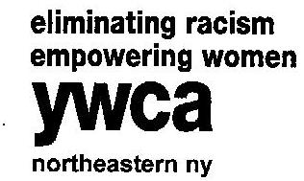

2016 Honorary Committee
Women of Achievement Awards Dinner

To be included on the invitation and program book,
Email to jrafalik@ywca-neny.org, the information by February 5, 2016.

To be included in our program book only, responses are needed by March 4, 2016.

 | I accept your invitation to be on the Honorary Committee for the 2016 Women of Achievement Dinner, $175.
 | I regret that I am unable to accept your invitation at this time but please accept my donation.
 | Amount enclosed: $ Please make check payable to: YWCA NorthEastern NY
 | Credit card information: |  |  | VISA |  | MASTERCARD
 |  |  |  | DISCOVER |  | American Express
 | Name:
 | Card No: |  |  |  |  |  | Exp. Date:
 | Signature:
 | Please print the proper listing of your name for the Invitation and program book:

Mail to:
YWCA NorthEastern NY
Jo-Anne Rafalik
44 Washington Ave.
Schenectady, NY 12305

