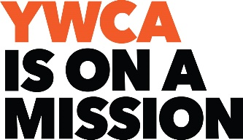

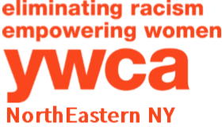

Women on a Mission Recognition

Do you know a woman in our community who is on a mission as a change agent, leader, or innovator in her workplace, volunteer work, neighborhood, non-profit, organization/ group, educational setting, faith/spiritual group, advocacy, etc.? In honor of the YWCA NorthEastern NY’s 35th Annual Women of Achievement Celebration & Fundraiser, we would like to recognize 35 women from our community who are on a mission.

The honorees will be recognized at the YWCA Women of Achievement Celebration & Fundraiser to be held Thursday, March 8, 2018 at The Glen Sanders Mansion in Scotia, NY. The deadline to submit an application is February 12, 2018 and may be emailed to funddevelopment@ywca-neny.org or mailed to Women on a Mission, YWCA NorthEastern NY, 44 Washington Avenue, Schenectady, NY 12305. Should you have any questions, call Jo-Anne Rafalik at the YWCA, 518-374-3394 ext. 105 or email funddevelopment@ywca-neny.org.

Price | Includes
$300 | - Two (2) dinner tickets ($180 value)  - Recognition for honoree:  - during Women of Achievement Celebration & Fundraiser  - in Women of Achievement Program Book  - in Women of Achievement PowerPoint  - on YWCA NorthEastern NY’s website  - in a special announcement in The Daily Gazette  - on YWCA NorthEastern NY’s social media
$750 | - Eight (8) dinner tickets ($720 value)  - Recognition for honoree:  - during Women of Achievement Celebration & Fundraiser  - in Women of Achievement Program Book  - in Women of Achievement PowerPoint  - on YWCA NorthEastern NY’s website  - in a special announcement in The Daily Gazette  - on YWCA NorthEastern NY’s social media
This is a non-competitive award, meant to honor women in our community who make a difference. Only 35 honorees will be given this distinction.

Women on a Mission Information Form

Honoree Information:
Name: ________________________________________________________________
Address: ______________________________________________________________
Phone: _______________________________________________________________
Email: ________________________________________________________________

Person Submitting Form:
Business/Organization/Affiliation: ___________________________________________
Contact Person: ________________________________________________________
Address: ______________________________________________________________
Phone: _______________________________________________________________
Email: ________________________________________________________________

Recognition Level: ☐ $300 ☐ $750
Payment Information: ☐ Check (made payable to the YWCA NENY)
☐ Visa ☐ MasterCard ☐ Discover ☐ American Express
Name on Card: _________________________________________________________
Card Number: _____________________________________ Exp. Date: ___________
Signature: _____________________________________________________________
Billing Address: _________________________________________________________

In a few words, describe how the honoree has been a change agent, leader, or innovator in one or more of the following areas:
• Workplace • Volunteer work
• Neighborhood • Non-profit
• Group/organization • Educational setting
• Faith/spiritual group • Advocacy
• Other: _________________

______________________________________________________________________
______________________________________________________________________
______________________________________________________________________
______________________________________________________________________

